Predication of Loan Default with Machine Learning

1.Abstract
In statistical modeling, classification is the problem of identifying to which of a set of a new observation belongs, on the basis of a training set of data containing observations whose category membership is known[1] ,from Wikepedia.
Classification is a supervised model, often done with logistic regression or a similar procedure, here I choose Decision tree learning and Support Vector Machines. Logistic regression is the appropriate regression analysis to conduct when the dependent variable is binary and independent variable are various types. Decision tree learning uses a decision tree as a predictive model to go from observations about an item, represented in the branches, to conclusions about the item's target value (represented in the leaves, normally categories value )[2], from Wikepedia. Support vector machines (SVMs) are supervised learning models as well, with associated learning algorithms that analyze data used for classification and regression analysis[3].
Loan default is the failure to repay a loan according to the terms agreed to in the promissory note. To predict whether an application will likely default on the loan or not is very import for banks or credit companies. In this report, I will show how to build ‘Logistic regression model’, ‘Decision Tree model’, and ‘SVMs’ with R-studios. Compare the accuracy of prediction for three models then predict some applications with the best model.[4]

Keywords: classification, logistic regression, decision tree, support vector machines.

Predication of Loan Default with Machine Learning

- Background about the data.

There are three datasets in this report. ‘applications.csv’ is a home loan application dataset. This dataset is for prediction whether an application will likely default on the loan or not. It has 260k+ applications with 100+ features. The dataset contains 2 classes under the TARGET column: 0 as no default and 1 as default. In this report, all classification models are built to predict the TARGET column.
Furthermore, another dataset file (history.csv) is provided which contains the monthly balance of applicants’ previous loans. Some applicants will have previous history while others not. The two files are cross referenced by the SK_ID_CURR column. A test file, ‘application_test.csv’ is provided for get outcome of the models.

- How to implement data.

2.1 Software tools.
R is a language and environment for statistical computing and graphics [5]. R version 3.5.1 is used in this paper. Rstudio 1.1.414, a graphical user interface of R, is implemented to demonstrates my process of model and output.
Weka, version 3.9.3, a suite of machine learning software, works for feature selection in this paper. [6]
Python 3 deales with missing data and merging tables.
PyCharm, version 2018.2.2, is an integrated development environment (IDE) used in computer programming, specifically for the Python language.
2.2 Three models in this paper.
2.2.1 Model one, logistic regression model.
2.2.2 Model two, decision tree model.

2.2.3 Model three, support vector machines.

2.3 How to preprocess the data.

2.3.1 Delete all rows with missing data in files ‘appliation.csv’ and ‘history.csv’ in Python3.

import pandas as pd
import csv
#import two datasets 'applications' and 'history',all missing data replaced with 'NaN'
applications = pd.read_csv('/Users/bonnyxin/Desktop/632/Project/Project2/applications.csv')
history = pd.read_csv('/Users/bonnyxin/Desktop/632/Project/Project2/history.csv')
# delete rows with missing data
applications=applications.dropna(
axis=0, # 0: work with rows; 1: work with column
how='any' # 'any': drop rows with any 'Nan'; 'all': drop rows only when all values are 'NaN'.
)
history=history.dropna(
axis=0,
how='any'
)
# export new datasets
applications.to_csv('/Users/bonnyxin/Desktop/632/Project/Project2/applications_nomissing.csv',index=False,header=True)
history.to_csv('/Users/bonnyxin/Desktop/632/Project/Project2/history1.csv',index=False,header=True)

2.3.2 Selects features with Weka.

2.3.2.1 Selects features from ‘applications_nomissing.csv’ .
‘After importing file ‘applications_nomissing.csv’ to Weka, I choose evaluator ‘ReliefFAttributeEval’, and ‘Ranker’ as search method. ‘ReliefFAttributeEval’ evaluates the worth of an attribute by repeatedly sampling an instance and considering the value of the given attribute for the nearest instance of the same and different class. It can operate on both discrete and continuous class data. After ranking, 11 top attributes are selected, plus attributes ‘SK_ID_CURR’ and ‘TARGET’, total 13 attributes generate new file ‘applications_relief.csv’.
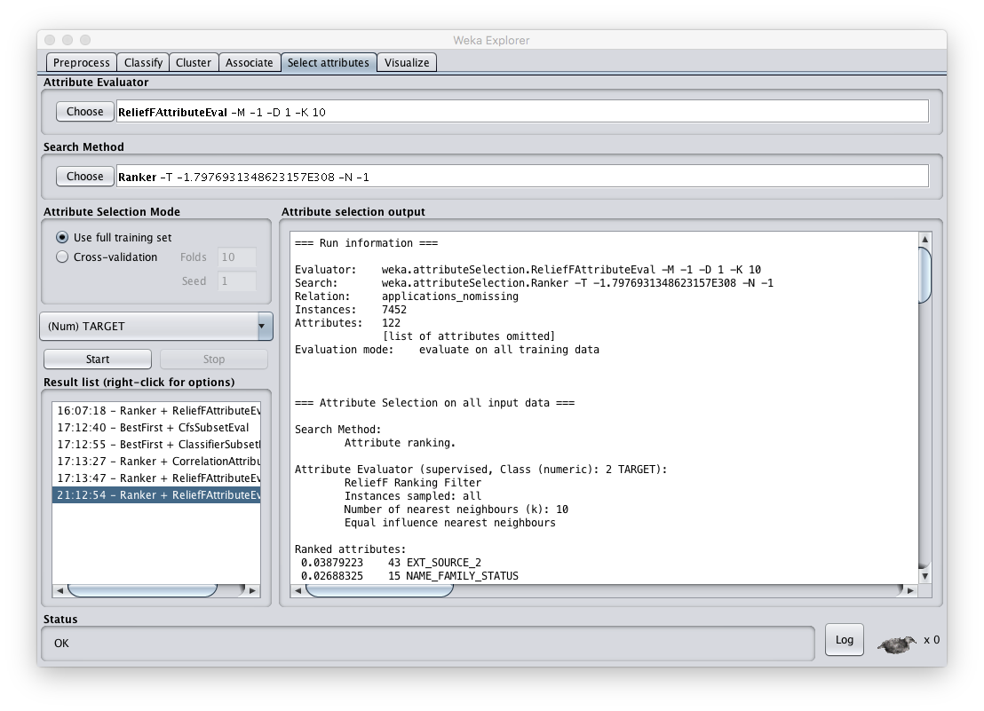

2.3.2.2 Inner Merge ‘applications_relief.csv’ and ‘history.csv’ with python.

import pandas as pd
innerMerge_updated = pd.merge(applications_relief, history1, on='SK_ID_CURR')

2.3.2.3 Selects features from file ‘ innerMerge_updated’ with Weka .
Below table is the ranking list.

TABLE1 Ranking list
Ranking | Relief_values | Attributes_name
1 | 0.0890198 | EXT_SOURCE_1
2 | 0.0875239 | EXT_SOURCE_3
3 | 0.0848692 | SK_ID_CURR
4 | 0.0842769 | EXT_SOURCE_2
5 | 0.0629331 | SK_ID_PREV
6 | 0.0346215 | CNT_INSTALMENT
7 | 0.0307157 | MONTHS_BALANCE
8 | 0.0089641 | REGION_RATING_CLIENT
9 | 0.0075691 | DEF_30_CNT_SOCIAL_CIRCLE
10 | 0.0048923 | AMT_REQ_CREDIT_BUREAU_WEEK
11 | 0.0022434 | DEF_60_CNT_SOCIAL_CIRCLE
12 | 0.0017762 | NAME_HOUSING_TYPE
13 | 0.0012683 | NAME_FAMILY_STATUS
14 | 0.000124 | FLAG_WORK_PHONE
15 | 0.0000167 | REG_CITY_NOT_WORK_CITY
16 | -0.00005 | SK_DPD_DEF
17 | -0.0004425 | SK_DPD
18 | -0.0109823 | NAME_CONTRACT_STATUS
19 | -0.0317129 | CNT_INSTALMENT_FUTURE

GRAPH 1
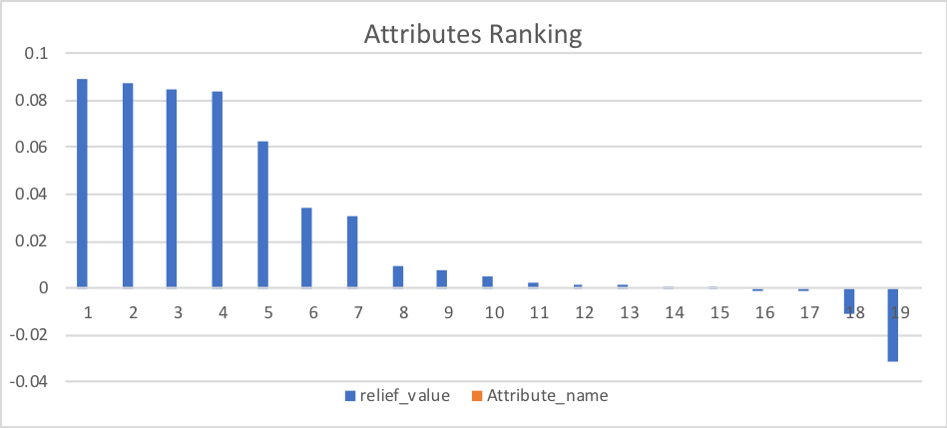
2.3.2.4 Combine two files.

According to TABLE1 and GRAPH1, attributes ‘MONTHS_BALANCE’ and ‘SK_ID_PREV ‘ from ‘history.csv’ file are ranking high. Therefore, I group by distinct value in column ‘SK_ID_PREV’ and average values in column ‘‘MONTHS_BALANCE’ , then generate a new ‘history.csv’ file. After that, merge the new file with ‘applications_relief.csv’ . A full file for the model named ‘innerMerge_updated3.csv’ is generate. It has 15 attributes and 6957 samples. This file is the one I use for building and testing the models.
2.3.3 Separate file ‘innerMerge_updated3.csv’ to train’ and test files.

Since there are 6957 samples, I will put 5000 samples in file ‘train’ and others in file ‘test’. Some attributes like ‘FLAG_WORK_PHONE’ supposed to be type factor, but they are type integer now. I need transform them to type factor.

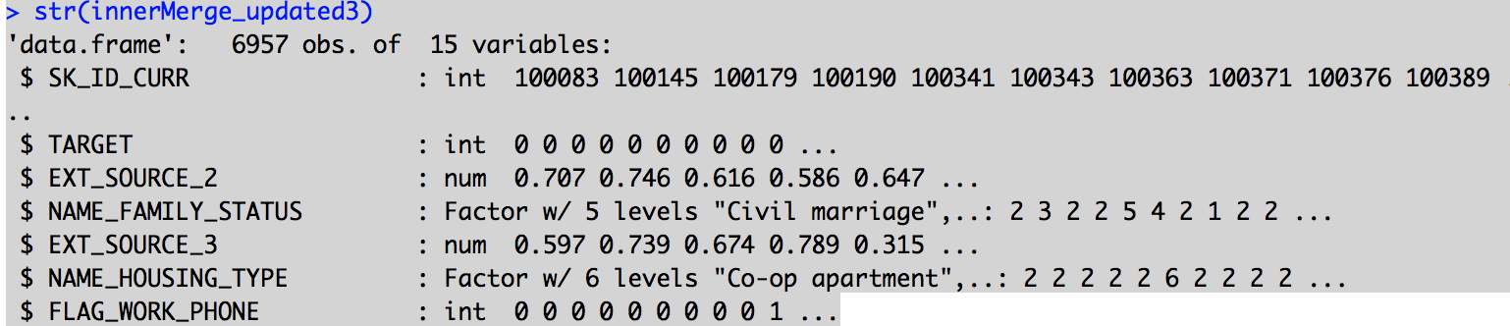

2.3.3.1 Clean up the data before separating.
Run below codes in R.
> dataset=innerMerge_updated3
> str(dataset). (show structures of all the attarbutes.)
> dataset$FLAG_WORK_PHONE<-as.factor(dataset$FLAG_WORK_PHONE)
> dataset$DEF_30_CNT_SOCIAL_CIRCLE<-as.factor(dataset$DEF_30_CNT_SOCIAL_CIRCLE)
> dataset$DEF_60_CNT_SOCIAL_CIRCLE<-as.factor(dataset$DEF_60_CNT_SOCIAL_CIRCLE)
> dataset$REGION_RATING_CLIENT<-as.factor(dataset$REGION_RATING_CLIENT)
> dataset$REG_CITY_NOT_WORK_CITY<-as.factor(dataset$REG_CITY_NOT_WORK_CITY)
> dataset$REG_CITY_NOT_WORK_CITY<-as.factor(dataset$REG_CITY_NOT_WORK_CITY)
> dataset$TARGET<-as.factor(dataset$TARGET)
> dataset$SK_ID_CURR<-as.factor(dataset$SK_ID_CURR)

2.3.3.2 Separate the file.
> s<-sample(6957,5000)( Generate 5000 random number in range 0 to 5000)
> train<-dataset[s,] (Select 5000 samples from dataset based on index number as s.)
> test<-dataset[-s,] (Select the left 1957 samples from dataset to be test.)

2.4 Implementation of the three models.

2.4.1 Model one, logistic regression model.

Mathematically, logistic regression estimates a multiple linear regression function defined as:[7]
logit(p)
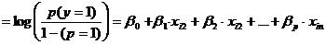
for i = 1…n .

when logit(p) = x, p = e^(x)/(1+e^x)

Run below code in R studio to build the model and compute the predicted output.

>md3<-glm(TARGET~ .,data=train,family = "binomial") (Build the model)
> p= predict(md3,newdata=train,type = "response") (Compute the predicated value for train dataset)
> p.target=round(p)
> require(caret)
> train$TARGET<-as.factor(train$TARGET)
> confusionMatrix(p.target,train$TARGET) (Compare the predicted output and original output)

I will compare predicted outputs of all three models in 2.4.4.

2.4.2 Model two, decision tree model.

The goal of decision tree learning is to create a model that predicts the value of a target variable based on several input variables. An example is shown in the diagram below. Each interior node corresponds to one of the input variables; there are edges to children for each of the possible values of that input variable. Each leaf represents a value of the target variable given the values of the input variables represented by the path from the root to the leaf.[3] from Wikipedia.
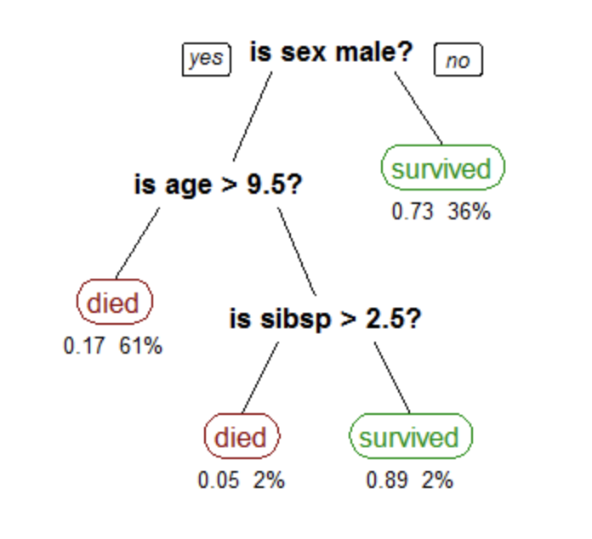
Running code in R-studio.
Rpart package recursively partition for classification, regression and survival trees.

>library(rpart)
>dtm <- rpart(TARGET~.,data = train,method="class",control =rpart.control(minsplit =10,minbucket=1, cp=0))

Parameter explanation:
Parameter method = "class" is for classification, when the Y value is binary.
Parameter ‘Minsplit’ is the minimum number of observations that must exist in a node in order for a split to be attempted.
Parameter ‘minbuket’ is the minimum number of observations in any terminal <leaf> node.
Parameter ‘cp’: complexity parameter. Any split that does not decrease the overall lack of fit by a factor of cp is not attempt.
All above information are from R document.

>p_dtree= predict(dtm,newdata=train,type = "class")(Compute predicted values)
> confusionMatrix(p_dtree,train$TARGET)(Generate confusion Matrix)

2.4.3 Model three, support vector machines.

A support vector machine constructs a hyperplane or set of hyperplanes in a high- or infinite-dimensional space, which can be used for classification, regression, or other tasks like outliers detection. Intuitively, a good separation is achieved by the hyperplane that has the largest distance to the nearest training-data point of any class (so-called functional margin), since in general the larger the margin the lower the generalization error of the classifier[3], from wekipedia.
Build a SVMs in Rstudio as below.
> trctrl <- trainControl(method = "repeatedcv", number = 10, repeats = 3)
> set.seed(3233)
> svm_Linear <- train(TARGET ~., data = train, method = "svmLinear",
+ trControl=trctrl,
+ preProcess = c("center", "scale"),
+ tuneLength = 10)
> svm_Linear
> confusionMatrix(test_pred,train$TARGET)

Parameter method = "repeatedcv", is for repeated training/test splits
Parameter ‘number’ is either the number of folds or number of resampling iterations
Parameter ‘repeats’ is for repeated k-fold cross-validation only: the number of complete sets of folds to compute.
Parameter ‘preProcess’ is a string vector that defines a pre-processing of the predictor data, here I choose ‘center’ and ‘scale’
Parameter ‘tuneLength’ denotes the amount of granularity in the tuning parameter grid.
Above explanation are from R documents.

2.4.4 Accuracy comparison of prediction with table ‘train’ for three models.

TABLE 2

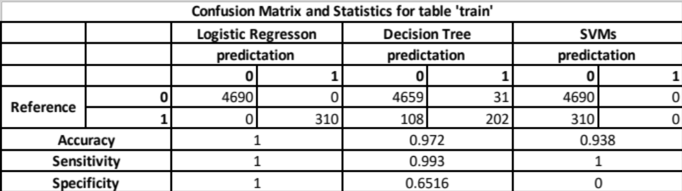

TABLE 2 is the confusion matrix [8] for all three models based on the predicted output and original value in attribute ‘TARGET’ in file ‘train’. ‘0’ means the application will not have loan default, ‘1’ means the application has more probability to be fail to pay the loan back.
Accuracy is the data which has been predicted correct to the total amount sample.
Sensitivity is the probability of original value was 0 has been detected by the model.
Specificity is the probability of original value was 1 has been detected by the model.
Thus, the greater these parameters are, the better the model is.
Such as, in Decision tree model:
Accuracy = (4659+202)/5000 = 0.972
Sensitivity = 4659/(4659+31) =0.993[9]
Specificity =202/(202+108) = 0.6516
For loan default detection, the rate of specificity, which denotes the probability of application will have loan default is more important. A good detector will save huge loss of bank or credit company.
Based on TABLE 1, all models are good at detected good customers, meanwhile, ‘decision tree model’ works better on detecting bad customers.

2.4.5 Accuracy comparison of prediction with table ‘test’ for three models.

Now it is time to run table ‘test’ on above three models.
TABLE 3 are the output of three models.
TABLE3
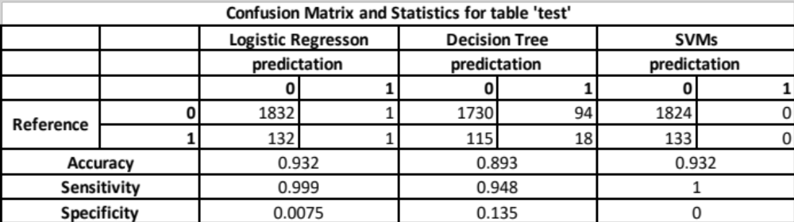

According to TABLE3, accuracy and sensitivity for all three models are around or more than 0.9. But the difference of specificity are big, therefore, I will choose Decision Tree as the best model. And predict the output for file ‘appliocation_test.csv’.
2.5 Implement predication for ‘application_test.csv’ with ‘Decision Tree Learning Model’.
As above procedure, I will delete all rows with missing value in ‘appliaiton_test.csv’ and then merge new file with ‘history1.csv’. After that, run ‘Decision tree model’ in the merged file. Total 13486 samples and 14 attributes are in file ‘innerMerge_test.csv”
After computing as below, total 12432 applications will be good customers, and 1054 customers will not pay loan back.
> pt_dtree= predict(dtm2,newdata=data_test,type = "class")
> summary(pt_dtree)
0 1
12432 1054

3. Conclusion
According to all outputs from above tests, we can see, in the real world, it is important to find the right model to uncover the data. Bad model can cause huge loss in the real world, for this project, improving the specificity for load default predicator are more important. In fact, most of the binary classification model gives the probability of the predication first, then generate values 0 and 1 base on certain threshold, normally round the value as 0.5. For bank loan prediction, banks want to reduce the potential harm from ‘bad customer’, then the threshold value can be set to be lower than 0.5. In this way, the detection of ‘bad customers’ will be more efficient. [10]
4. Reference
[1] Statistical classification
https://en.wikipedia.org/wiki/Statistical_classification

[2] Decision tree learning
https://en.wikipedia.org/wiki/Decision_tree_learning

[3] Support Vector Machine
https://en.wikipedia.org/wiki/Support_vector_machine

[4]. Loan Default Prediction - Imperial College London
https://www.kaggle.com/c/loan-default-prediction

[5] What is R ?
https://www.r-project.org/about.html

[6]. Weka (machine learning)
https://en.wikipedia.org/wiki/Weka_(machine_learning)

[7]. What is Logistic Regression?
http://www.statisticssolutions.com/what-is-logistic-regression/

[8]. Simple guide to confusion matrix terminology
https://www.dataschool.io/simple-guide-to-confusion-matrix-terminology/

[9]. Sensitivity and specificity
https://en.wikipedia.org/wiki/Sensitivity_and_specificity

[10]. Bank Loan Default Prediction with Machine Learning
https://medium.com/henry-jia/bank-loan-default-prediction-with-machine-learning-e9336d19dffa

